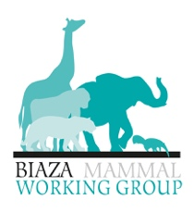

**Marwell’s Antelope Conference 2025**

Call for speakers! Let’s talk everything antelope! We are looking for industry professionals to present at our Antelope Conference here at Marwell Zoo on the 17th and 18th of September 2025. We are looking for talks and posters to cover an array of topics specific to antelope including training, welfare, nutrition, husbandry, conservation, and more.

We are looking for talks of 10 and 20 minutes (can be altered on an individual basis if necessary). Talks will be held in the lecture theatre. Posters selected will be displayed during the conference.

Please email this completed form to: zoen@marwell.org.uk

|  |  |
| --- | --- |
| **Talk/Poster Request Form** | |
| Name and Job Title: |  |
| Email: |  |
| Organization: |  |

|  |  |
| --- | --- |
| Title of talk/poster: |  |
| Brief synopsis: |  |
| Duration of talk:  *(Please tick one).* | 10 minutes  20 minutes  *(Request for more time, please explain here......)* |
| Which day/s are you attending?  *(Please tick one).* | Wednesday 17th Thursday 18th Both |